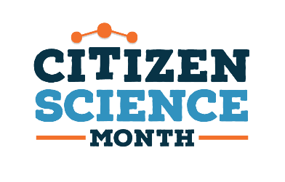
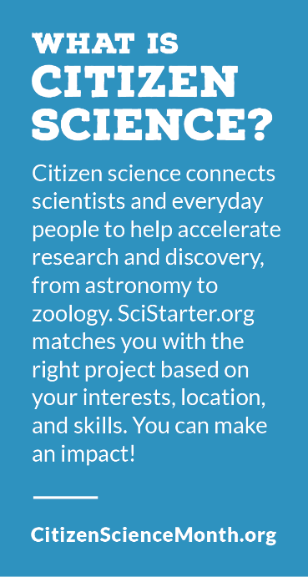
Astronomy & Space
Check out both the library’s physical and digital downloads to find materials to support astronomy and other space related citizen science projects found on SciStarter.org.

Adult & Teens Nonfiction

Cavalier et al. (2020). The field guide to citizen science: How
you can contribute Scientific research and make a
difference, Portland: Timber Press.

Consolmagno, G., Davis, D. (2019). Turn left at Orion:
hundreds of night sky objects to see in a home telescope
– how to find them. New York: Cambridge University Press.

Fazekas, A. & Schneider, H. (2019). National Geographic
Backyard Guide to the Night Sky, 2nd Edition.
Washington, DC: National Geographic Society.

Regas, D. (2017). 100 Things to see in the night sky: from planets
and satellites to meteors and constellations, your guide to
stargazing. New York: Adams Media.

Stimac, V., (2019). Dark skies: a practical guide to astrotourism.
Carlton, Victoria: Lonely Planet.

Videos
International Dark-Sky Association. (2013, February 27). Losing
the dark. – Flat Screen Version [Video]. YouTube.
https://www.youtube.com/watch?v=dd82jaztFIo

Filippenko, A. (2011). Skywatching [kit]: seeing and
understanding cosmic wonders. [videorecording, PDF].
Chantilly, VA: The Teaching Company.

Children’s Nonfiction

Betts, B., Colon, E. (2018). Astronomy for kids: How to explore
outer space with binoculars a telescope, or just your eyes!
Emeryville, CA: Rockridge Press.

Crelin, B., & Ziner, A. (Illustrator). (2007). There Once Was a
Sky Full of Stars. Cambridge, MA: Sky Publishing.

Drimmer, S. (2017). Night sky. Washington, DC: National Geographic.

Edwards, N., & Cartwright, L. (Illustrator). (2019). When the stars come out. London: 360
Degrees, an imprint of Little Tiger Group.

Galet, J. (2017). Dark matter: nature’s reaction to light pollution. Brighton, Massachusetts: Red
Deer Press.

Gifford, Clive. (2019). Super space encyclopedia : the furthest, largest, most incredible features
of our universe. New York : Dorling Kindersley Publishing, Incorporated.

Hamilton, M. (Rev. ed). (2019). A child’s introduction to the night sky. New York, New York:
Black Dog & Leventhal.

Latta, S. (2018). Exploring constellations. North Mankato, Minnesota: Capstone Press.

Lasky, Kathryn & Swaney, Julianna (Illustrator). (2021). She caught the light: Williamina
Stevens Fleming: astronomer. New York: Harper, an imprint of HarperCollins Publishers.
Star finder!: A step-by-step guide to the night (1st ed.). (2017). New York, NY. DK.

Read, J.A, (2018). 50 Things to see with a telescope: a young stargazer’s guide. Halifax, Nova
Scotia: Stellar Publishing.

Picture Books

Krishnaswami, Uma & Sicuro, Aimée. (2015). Bright sky, starry city. Toronto, Ontario:
Groundwood Books.

Mercurio, Ishta. (2019). Small World. New York : Abrams Books for Young Readers.

Motum, Marus. (2017). Curiosity: The story of a Mars rover. Somerville, MA: Candlewick Press.

Solitis, Sue & Davenier, Christine (Illustrator). (2020). The stars just up the street. Somerville,
MA: Candlewick Press.

Wilson-Max, Ken, (2019). Astro girl. Somerville, MA: Candlewick Press.

