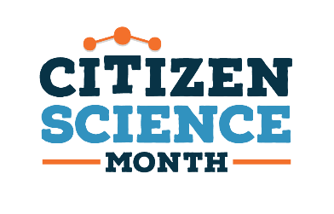
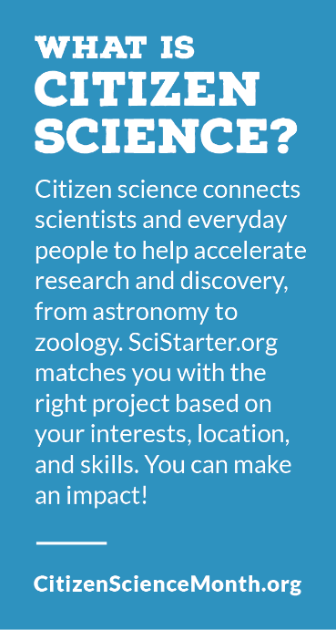
Citizen Science Books

Adult and Teen

Cavalier, Darlene and Kennedy, Eric B. (2016). The Rightful Place
of Science: Citizen Science. Tempe, AZ: Consortium for
Science, Policy & Outcomes. Arizona State University.

Cavalier, Darlene; Hoffman, Catherine, Cooper, Caren. (2020).
The field guide to citizen science how you can contribute to
scientific research and make a difference. Portland, Oregon:
Timber Creek Press.

Clark, Anna. (2018). The poisoned city: Flint’s water and the
American urban tragedy. New York: Metropolitan Books,
Henry Holt and Company.

Cooper, Caren. (2016). Citizen Science: How Ordinary People are
Changing the Face of Discovery. New York: Overlook Press.

Hannibal, Mary Ellen. (2017). Citizen scientist: searching for
heroes and hope in an age of extinction. New York: The
Experiment, LLC.

Hecker, S., Haklay, M., Bowser, A., Makuch, Z., Vogel, J., & Bonn,
A., (Eds.). (2018). Citizen science: innovation in open science,
society and policy. London: University College London Press.

Hulick, Kathryn. (2020). Citizen science: how anyone can
contribute to scientific discovery. San Diego, CA:
Reference Point Press.

Johnson, A. E. & Wilkinson, K. K. (Eds.). (2020). All we can save:
truth, courage, and solutions for the climate crisis. New York:
One World.

Lepczyk, C. A., Boyle, O. D., Vargo, T. L., & Noss, R. F. (2020).
Handbook of Citizen Science in Ecology and Conservation.
Oakland, California: University of California Press.

Children’s Nonfiction

Buzzeo, Toni and Holly Berry. (2015). A Passion for Elephants: The Real Life Adventure
of a Field Scientist. New York: Dial Books for Young Readers.

Cooper, Candy J. & Aronson, Marc. (2020). Poisoned water: how the citizens of Flint, Michigan,
fought for their lives and Warned the nation. New York: Bloomsbury
Children’s Books.

Fontichiaro, Kristin. (2018). Citizen Science. Ann Arbor, Michigan: Cherry Lake Publishing.

Forrester, Anna & Detwiler, Susan. (Illustrator). (2017). Bat count: a citizen science
collection. Mt. Pleasant, SC: Arbordale Publishing.
Lee Heinecke, Liz. (2016). Outdoor science lab for kids: 52 family-friendly experiments for
the yard, garden, playground, and park. Beverly, Massachusetts : Quarry Books.
Kovacs, Vic. (2018). Get into citizen science. New York: Crabtree Publishing Company.

Meeg, Pincus. Imamura, Yas (Illustrator). (2020). Winged Wonders: Solving the
monarch migration mystery. Ann Arbor, Michigan: Sleeping Bear Press.

Perdew, Laura. (2019). Biodiversity: explore the diversity of life on Earth with environmental
science activities for kids. White River Junction, VT: Nomad Press.

Picture Books

Bathala, Neeti. (2017). Moonlight crab count. Mt, Pleasant, SC: Arbordale Publishing.
(Available in Spanish)

Cousteau, Philippe. Hopkinson, Deborah. So, Meilo (Illustrator). (2016). Follow the moon home: a tale of one idea, twenty kids and a hundred sea turtles. San Francisco, California: Chronicle
Books LLC.

Farrell, Alison. (2019). The hike. San Francisco, California: Chronicle Books LLC.

Paul, Miranda & Zunon, Elizabeth (Illustrator). (2015). One plastic bag: Isatou Ceesay and the
recycling women of the Gambia. Minneapolis: Millbrook Press.

