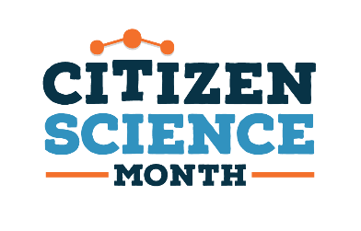
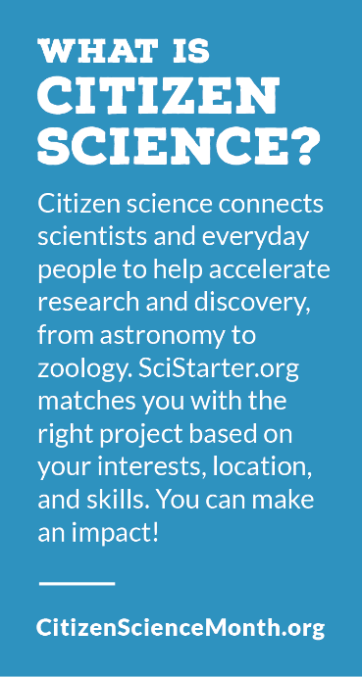
Pollinators
Books that will provide a deeper understanding of pollinators, and how they make 35 percent of the world’s food production possible.

Adult & Teens Nonfiction
Cavalier et al. (2020). The field guide to citizen science: How you
can contribute Scientific research and make a difference,
Portland : Timber Press.

Eierman, Kim. (2020). The pollinator victory garden: win the war
on pollinator decline with ecological gardening. Beverly, MA :
The Quarto Group.

Harris, Tim. (2020). Know your pollinators. Mount Joy, PA : Old
Pond Publishing.

Hayes, Rhonda Fleming. (2015). Pollinator friendly gardening:
gardening for bees, butterflies, and other pollinators.
Minneapolis, MN : Voyageur Press

Helmer, Jodi. (2019). Protecting pollinators: how to save the
creatures that save our world. Washington, DC : Island Press.

Walker, Timothy. (2020). Pollination: the enduring relationship
between plant and pollinator. Princeton, New Jersey:
Princeton University Press.

Walliser, Jessica. (2020). the plant partners: North Adams, MA :
Storey Publishing.

Wilson, Joseph S., Carril, Olivia Messinger. (2015). The bees in
your backyard: a guide to North America’s bees. Princeton,
New Jersey : Princeton University Press.

Children’s Nonfiction
Baxter, Roberta. (2020). The Native pollinators: bats. Hallandale,
FL : Mitchell Lane Publishers.

Baxter, Roberta. (2020). The Native pollinators: bees. Hallandale,
FL : Mitchell Lane Publishers.
Baxter, Roberta. (2020). The Native pollinators: hummingbirds. Hallandale, FL : Mitchell Lane
Publishers.

Gaines, Joanna & Swaney, Julianna (Illustrator). (2019). We are gardeners. Nashville,
Tennessee : Tommy Nelson.

Guyton, John W. (2018). Bug lab for kids: family-friendly activities for exploring the amazing
world of beetles, butterflies, spiders, and other arthropods. Beverly, MA : Quarry Books

Schuh, Mari C. (2017). From soil to garden. Minneapolis : Lerner Publication.

Picture Books

Barton, Bethany. (2017). Give bees a chance. New York, New York: Viking.

Burleigh, Robert. (2020). Tiny bird: a hummingbird’s amazing journey. New York : Christy
Ottaviano Books, Henry Holt and Company.

Davies, Nicola. & Ray, Jane (Illustrator). Hummingbird. Somerville, MA : Candlewick Press.

Hurley, Jorey. (2020). Beehive. New York: Simon & Schuster Books for Young Readers.

Lamba, Marie. (2017). Green green: a community gardening story. New York : Farrar Staus
Giroux.

Laminack, Lester & LaMarche, Jim (Illustrator). (2018). The King of bees. Atlanta : Peachtree.

McQuinn, Anna & Beardshaw, Rosalind (Illustrator). (2014). LoLa plants a garden. Watertown,
MA : Charlebridge.

